Community support through CLAW helps save greyhound

Via animal1 by Jennifer Gerner

Jennifer Gerner
Wed, 05/27/2015

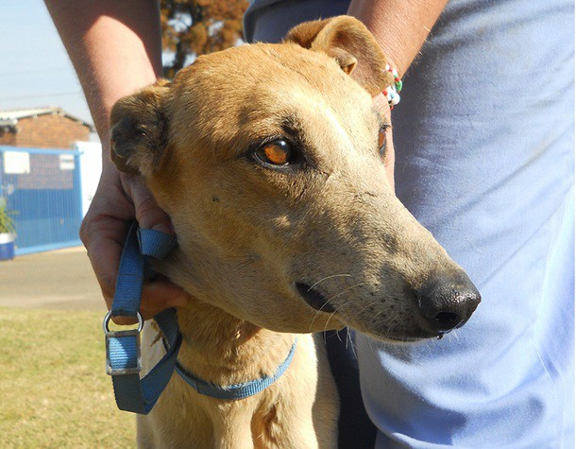

Early in the morning CLAW received a frantic phone call from a concerned citizen to say there was a skinny stray running about on a busy street near the “Township” waterworks.

read more

This file was saved from Inoreader

